R.Mrudula(12b4)
WEEK-10--Elasticbeanstalk

Prerequisites
- A web application ready (e.g., ROOT.war, .zip, or code)----YOU CAN YOURS MAVEN PROJECT HERE

Steps to Create Elastic Beanstalk Application
Step 1: Open Elastic Beanstalk
- Login to AWS Console
- Under Compute section ->Search for Elastic Beanstalk
- Click Create Application
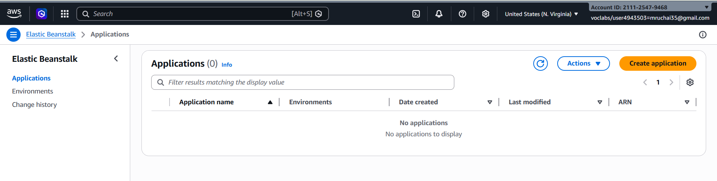

Step 2: Create Application
- Enter Application Name (e.g., MyApp)
- Add description (optional)
- Click Create
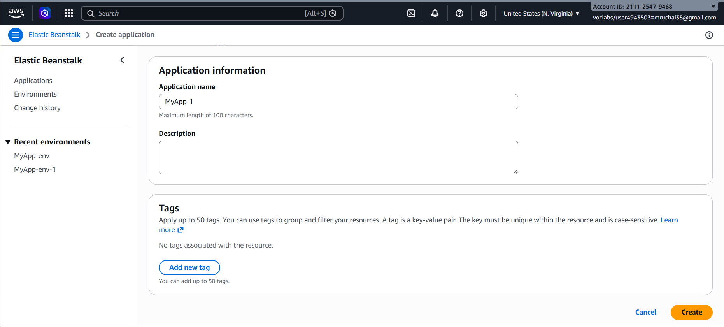

Step 3: Create Environment
- Click Create Environment
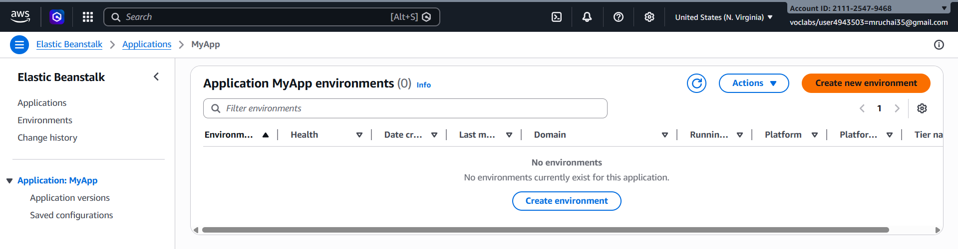
- Choose:
  - Web Server Environment (for web apps)
- Click Select
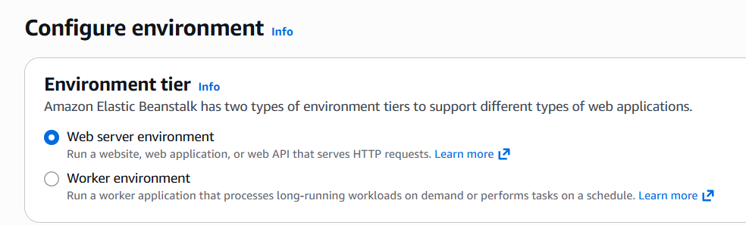

Step 4: Configure Environment
- Enter Environment Name
- Choose Platform:
  - Java (for .war)
  - Node.js / Python / PHP / etc.
- Under Application Code:
  - Select Upload your code
  - Upload your .war or .zip file
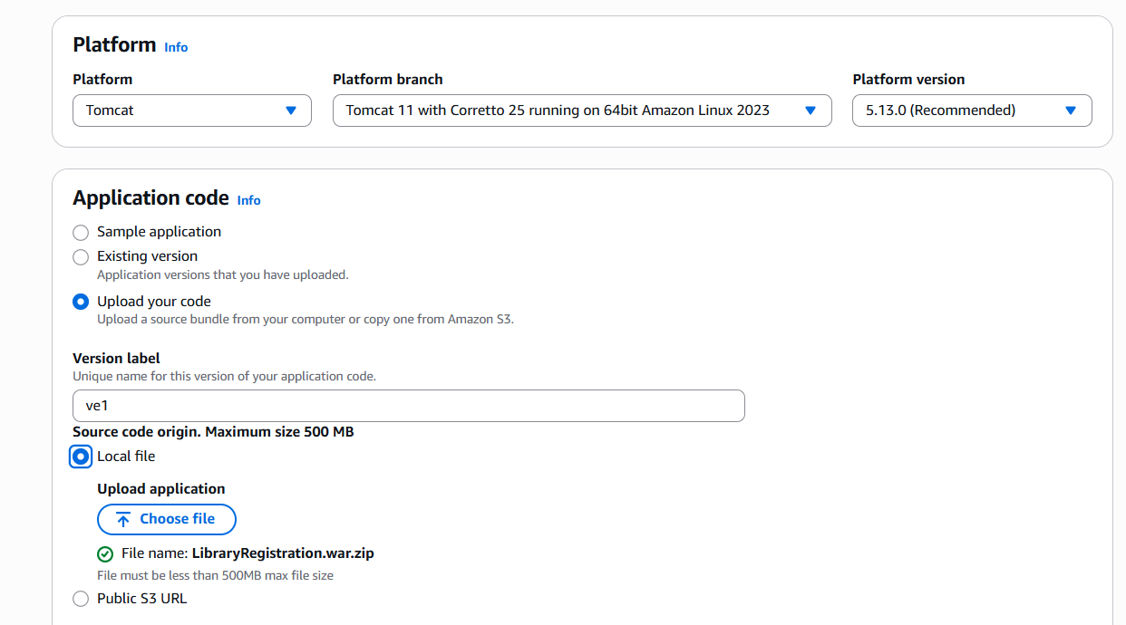

Step 5: Configure Service Access
- Service Role → Select existing -LabRole
- EC2 Key Pair → Optional (for SSH)
- EC2 Instance Profile → select (e.g., LabInstanceProfile)
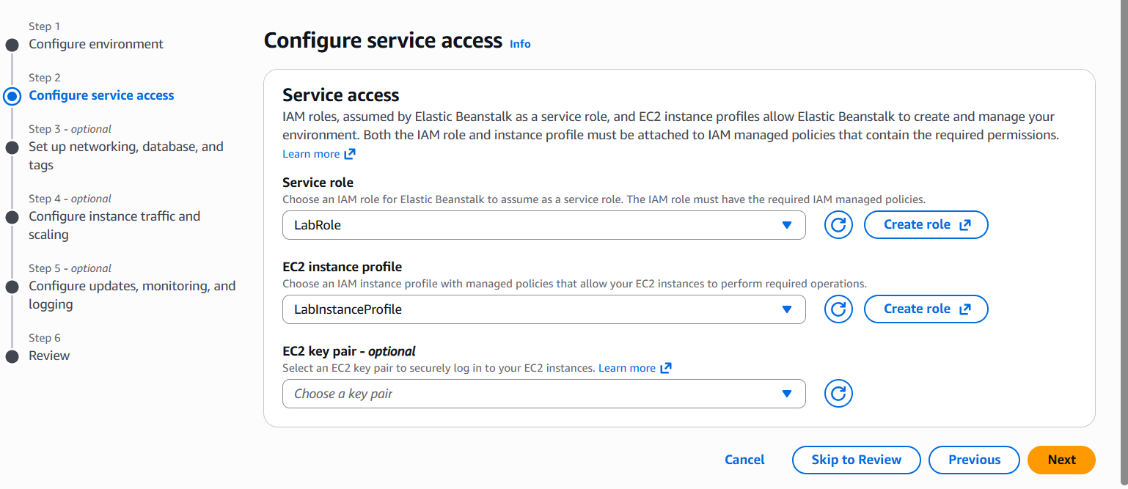

Step 6: Configure Network
- Select VPC (default is fine)
- Select Subnets
- Enable Public IP
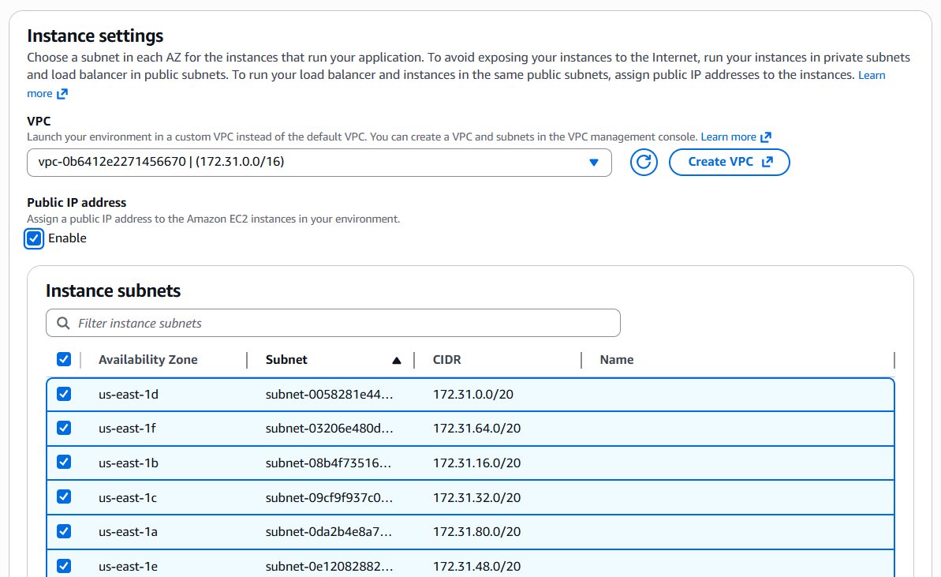

Step 7: Instance & Scaling Setup
- Choose Instance type (e.g., t2.micro – free tier)
- Set:
  - Min instances: 1
  - Max instances: 2 (or more)
- Load Balancer → Enabled (optional but recommended)

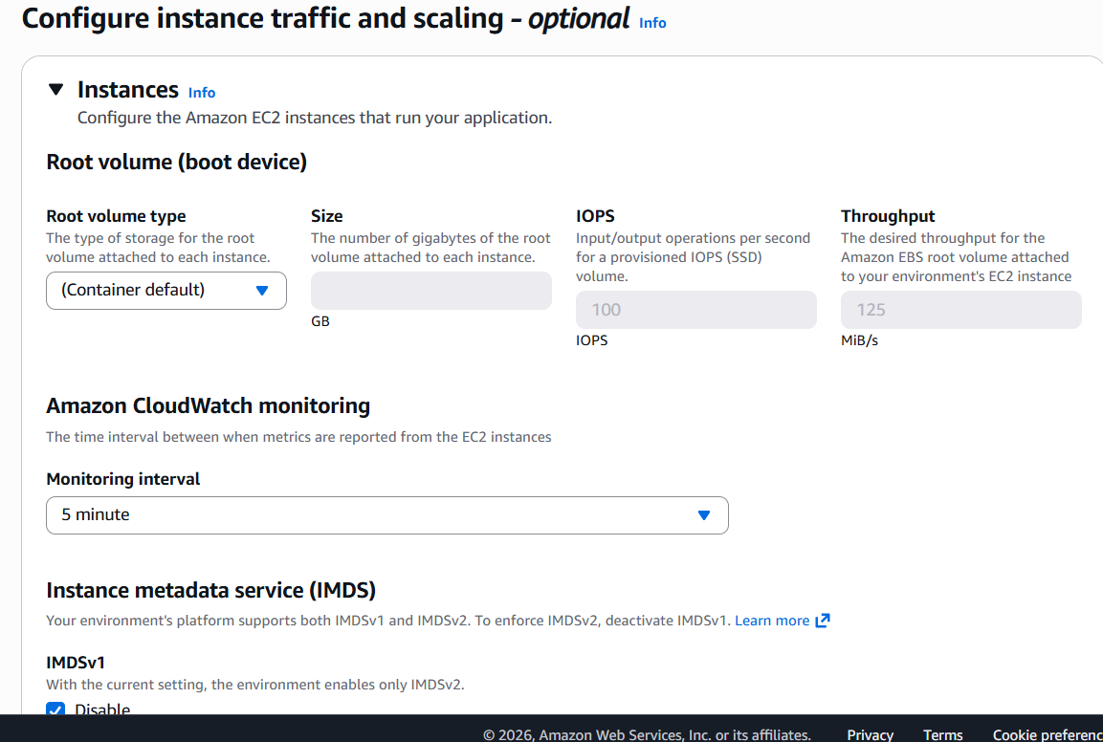
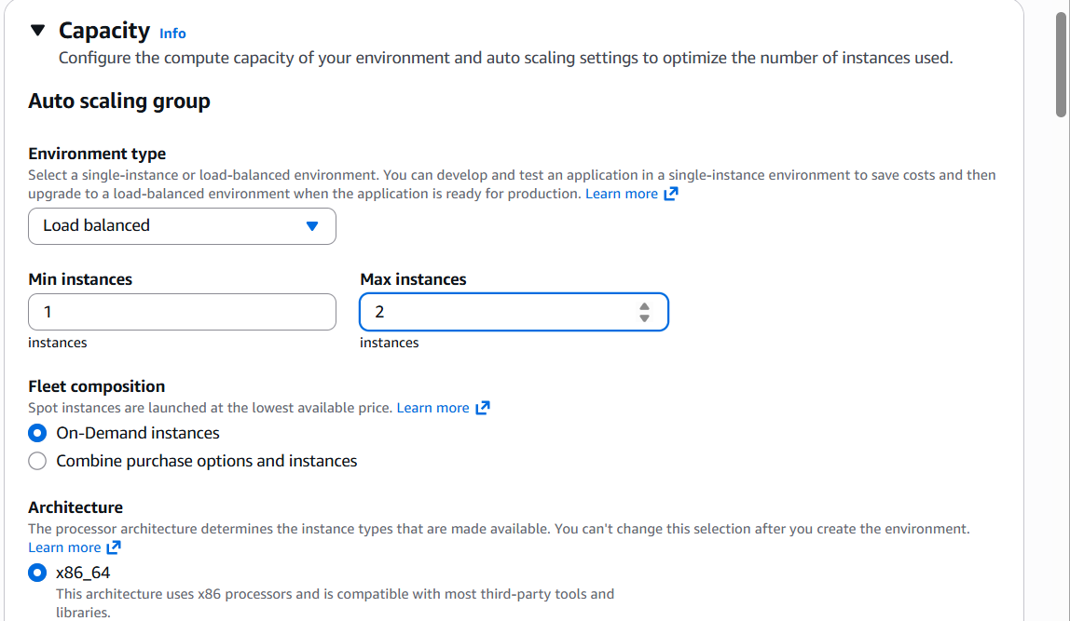

Step 8: Review & Create
- Click Review
- Click Create
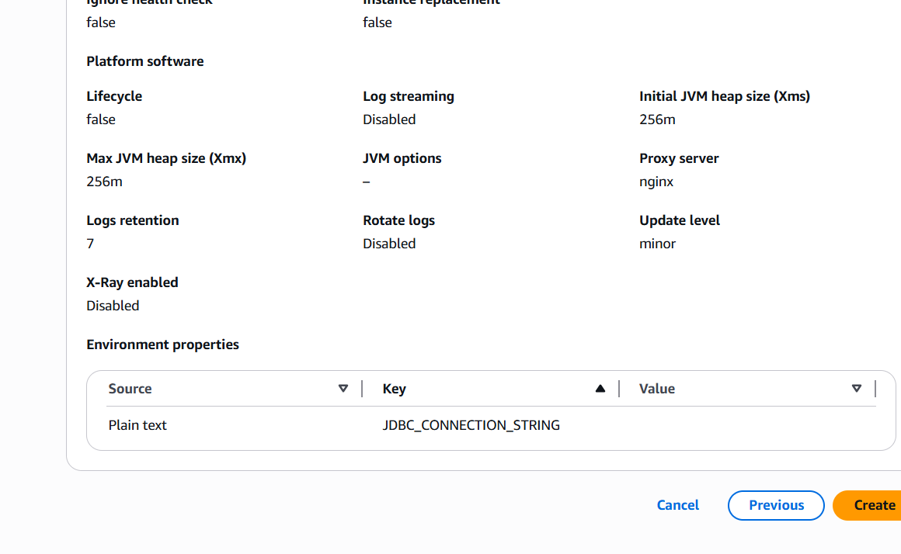

Deployment Process
- AWS automatically creates:
  - EC2 instances
  - Load Balancer
  - Auto Scaling Group
  - Security Groups

Access Your Application
- After deployment:
  - You will get a URL (domain link)
  - Open it in browser → Your app will run
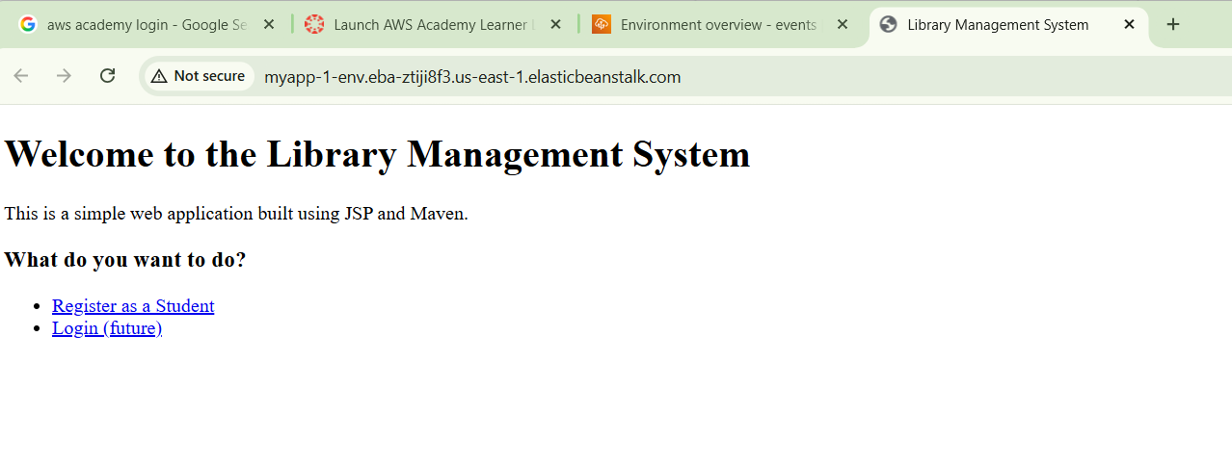


Updating Application
- Go to your environment
- Click Upload and Deploy
- Upload new version
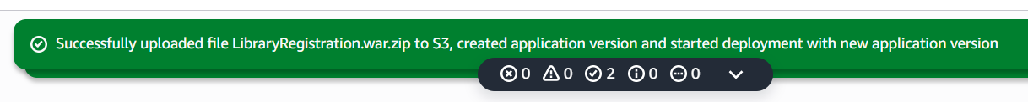

Scenario-Based Questions
Scenario 1: Application Not Loading
You deployed an application using Elastic Beanstalk, but the application does not load and shows an error page.
• What could be the possible reasons for this issue?
Ans:- Possible reasons include incorrect deployment, application crash, wrong configuration, missing dependencies, security group blocking traffic, or server not running properly.
• Could deployment or configuration be incorrect?
Ans:- Yes, incorrect deployment package, wrong environment variables, or misconfigured settings can cause the application to fail.
• How would you troubleshoot this problem?
Ans:- Check environment health status, review Events, inspect logs, verify security groups (port 80/443), ensure application is running, and validate configuration settings.

Scenario 2: Incorrect Application Structure
Your application is deployed, but the expected output is not displayed.
• How does application structure affect deployment in Elastic Beanstalk?
Ans:- Elastic Beanstalk expects a specific file structure; incorrect structure prevents proper execution of the application.
• What could happen if files are placed inside an extra folder?
Ans:- The platform may not detect the main application files, leading to errors or blank output.
• How would you fix the structure issue?
Ans:- Repackage the application ensuring all files are in the root directory (no extra parent folder) and redeploy.

Scenario 3: Wrong Platform Selection
While creating the environment, an incorrect platform was selected.
• Why is platform selection important in Elastic Beanstalk?
Ans:- The platform defines runtime environment, language support, and dependencies required to run the application.
• What kind of errors or behaviour might occur?
Ans:- Application may fail to start, show runtime errors, or not execute due to unsupported language/framework.
• How can you correct the platform without affecting the application?
Ans:- Create a new environment with the correct platform and redeploy the application.

Scenario 4: Environment Health Warning
The environment status shows Warning (Yellow) instead of healthy.
• What are possible reasons for this warning?
Ans:- High latency, failed health checks, application errors, insufficient resources, or configuration issues.
• Which sections (Events, Logs, Metrics) would you check first?
Ans:- Check Events for recent issues, Logs for application errors, and Metrics for CPU, memory, and response time.
• How can you resolve health issues?
Ans:- Fix application errors, adjust configurations, increase instance capacity, and ensure proper health check settings.

Scenario 5: Application Errors in Logs
Logs show a high number of application errors.
• What do such errors indicate?
Ans:- They indicate application failure, bugs, missing dependencies, or runtime issues.
• Could this be due to misconfiguration or missing resources?
Ans:- Yes, incorrect configurations or missing libraries/services can cause errors.
• How would you analyze logs to identify the root cause?
Ans:- Review error messages, identify patterns, check timestamps, and trace the issue back to specific code or configuration.

Scenario 6: Deployment Failure
The application deployment fails during upload.
• What could be wrong with the deployment package?
Ans:- Incorrect zip structure, missing files, unsupported format, or corrupted package.
• Which logs would you check to diagnose the issue?
Ans:- Deployment logs and Elastic Beanstalk Events.
• How can packaging errors affect deployment?
Ans:- The application may not deploy or execute properly due to missing or misplaced files.

Scenario 7: Works Locally but Not on Cloud
The application works correctly on a local machine but fails after deployment.
• What environment differences could cause this issue?
Ans:- Differences in OS, runtime version, environment variables, or installed dependencies.
• Could configuration or dependency issues be responsible?
Ans:- Yes, missing dependencies or incorrect configuration often cause this issue.
• How would you debug using cloud logs?
Ans:- Check application logs, compare with local setup, identify missing dependencies or errors, and fix accordingly.

Scenario 8: Blank Output
The application loads but shows no output.
• What could cause an application to display no output?
Ans:- Application not returning response, incorrect routing, or missing index file.
• Could runtime errors or misconfigurations be responsible?
Ans:- Yes, runtime failures or wrong configurations can result in blank output.
• How would logs help in identifying the issue?
Ans:- Logs show errors, failed requests, or missing files that help locate the problem.

Scenario 9: Application URL Not Accessible
The application URL is not accessible after deployment.
• Could the environment still be launching?
Ans:- Yes, the environment may still be in launching state.
• What status indicators should be checked?
Ans:- Check environment status (Launching/Ready), health status, and instance state.
• How can Events help identify the issue?
Ans:- Events show errors, failures, or progress messages during deployment.

Scenario 10: Resource Management Issue
After completing the lab, resources were not terminated.
• What are the cost implications of leaving resources running?
Ans:- Continuous billing occurs leading to unnecessary costs.
• Which AWS services continue running in the background?
Ans:- EC2 instances, Load Balancers, Auto Scaling Groups, Elastic IPs, and storage services.
• How can all resources be properly terminated?
Ans:- Terminate EC2 instances, delete environments, remove load balancers, and clean up associated resources.

Scenario 11: High Traffic Handling
The application receives sudden high traffic.
• How does Elastic Beanstalk handle scaling?
Ans:- It uses Auto Scaling to automatically increase or decrease instances based on traffic.
• What configurations should be enabled?
Ans:- Configure Auto Scaling policies, load balancer, and scaling triggers (CPU usage).
• What happens if scaling is not configured?
Ans:- Servers may overload, causing slow performance or application crashes.

Scenario 12: Application Update Not Reflected
Changes are made to the application, but users still see the old version.
• Could deployment issues be the reason?
Ans:- Yes, deployment may not have completed successfully.
• How can caching affect the output?
Ans:- Browser or server caching may display old content instead of updated version.
• How would you ensure the latest version is visible?
Ans:- Redeploy the application, clear cache, and verify deployment status.

